**Hackathon project – TEAM 1(Spidey Testers)**

**Book one way outstation cab and display the lowest charges**

**Automation**

**In Make My Trip Application**

**Problem Statement:**

 Book one way outstation cab and display the lowest charges

1. From Delhi to Manali, Himachal Pradesh.
2. Pick up from Delhi at 6.30 AM on 23rd Dec 2019
3. Car type should be SUV.

**Suggested Site:** <https://www.makemytrip.com/>

**Detailed Description:**

* Book one way outstation cab, From Delhi to Manali, Himachal Pradesh, give future date & time & Car type should be SUV; Display the lowest charges.
* Find Group Gifting in Gift Cards, fill card details & give invalid email; capture & display the error message.
* On the Hotel booking page, extract all the numbers for Adult persons and store in a List; Display the same.

**Key Automation Scope:**

* Handling alerts
* Filling simple form, Capture warning message
* Scrolling down in web page
* Extract dropdown items & store in collections
* Navigation from Menus
* Navigating back to home page

**Hackathon Project Frameworks & Tools Used:**

|  |  |
| --- | --- |
| **Frameworks & Tools** | **Version** |
| Selenium Java | 4.1.0 |
| WebDriver Manager | 5.0.3 |
| Maven | 4.0.0 |
| POM | 4.0.0 |
| TestNG | 7.4.0 |
| ExtentReports | 3.1.5 |
| Apache POI | 4.1.2 |

**Browser Options:**

1.Chrome

2.Firefox

3.Microsoft Edge

(The browser to be used while running the project is mentioned in the MakeMyTrip properties file (**MakeMyTrip.properties**) as browser, to run using various browser make changes in that field)

**Project Structure:**

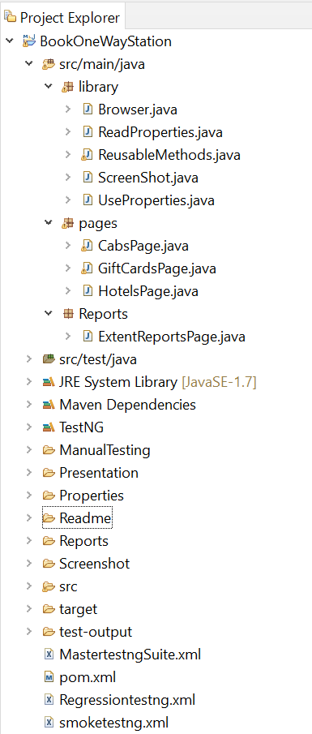

**Structure Details:**

1. **src/main/java**:

* library package ->Browser, Reusable Methods, ScreenShot, ReadProperties, UseProperties files.

(This package contains reusable and browser calling methods to be used in automation)

* Pages package ->CabsPage, GiftcardsPage, HotelsPage.

(This package contains pages to be automated)

* Reports package -> ExtentReportsPage.

(This package contains extent report files to create an extent report)

1. **src/test/java:**

* TestScript package ->MakeMyTripTest.

(This package contains the TestNG script to automate the code.

1. **Manual Testing:**

* The Manually tested and prepared testcase document

1. **Properties:**

* It contains the input data in both xlsx file and properties file

1. **Readme:**

* It contains the question and detailed explanation about the project file.

1. **Reports:**

* It contains the Extent Report for the automated project file.

1. **Screenshot:**

* It contains the screenshot taken during the execution of the program.

**Steps to Execute:**

1. Import the “BookOneWayStation” file into the eclipse workspace.
2. Save the pom.xml file.
3. Update the Maven project (Maven->Update Project).
4. To Run the program in respective browser such as Chrome, Firefox, Edge change the browser name in the MakeMyTrip properties file (Properties->MakeMyTrip.properties).
5. To Run both the smoke and regression test suites continuously right click on MastertestngSuite.xml file and click RunAs->TestngSuite.

**Extent Report:**

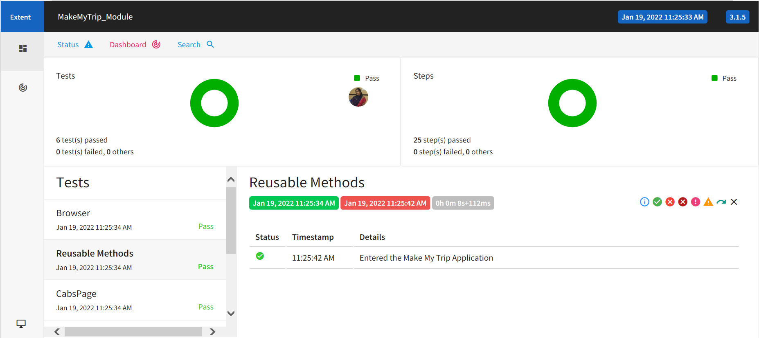

**Challenges:**

* While selecting the to city as Manali, Himachal Pradesh sometimes the cartype option was not displayed.
* Giftcards type Radio button doesn’t work.
* In Corporate giftcards details page when number is entered in place of a name text box it doesn’t shows an error.

**Team Members:**

* 1. Ajay D
* 2.Dhanush K
* 3.Nithiyashree R
* 4.Pradeep S
* 5.Renuga K
* 6.Soundarya S